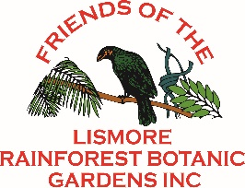
Friends of Lismore Rainforest Botanic Gardens Inc.
Special interests or other comments
www.friendslrbg.com.au
Incc
MEMBERSHIP FORM Date:
New Member
Renewal
Name(s):
Address:
Phone:
Mobile: Email:
Method of Payment
Direct Debit
NEWSLETTER
Cheque
By Post
Cash
On Line
I give permission for any photos taken relating to the Gardens which include me, to be used in publicity for the Lismore Rainforest Botanic Gardens – including the website. Please
indicate in the space provided that we have this permission.
Annual fees due 1 July each year
Individual $10
Donation $

TOTAL $

PAYMENT CAN BE MADE BY DIRECT DEBIT
BSB 728-728 Account 22205295
It is important for us to identify all monies received.
If you use Direct Debit please include your name and the fact that the payment is a sub. Please advise of payment by e-mail to: treasurer@friendslrbg.com.au
Postal Address: PO Box 1327 Lismore 2480

_

GENERAL INFORMATION

WEDNESDAY WORKDAYS
Each week from 8am till 11am.
Contact: Susan, Membership Secretary
Email: membership@friendslrbg.com.au

Wear hat, gloves and protective clothing.
Apply sunscreen and insect repellant as needed. Bring something for morning tea.

For other information

Contact: Florence, Secretary
Email: secretary@friendslrbg.com.au

For What’s Happening at the Gardens
and to access our newsletters visit:
www.friendslrbg.com.au

PLEASE RETURN YOUR COMPLETED FORM TO:
membership@friendslrbg.com.au
☞

